Today we look at the Big Mountain Resort at Glacier National Park with 105 trails and a yearly visitor of 350,000. A resort with 11 lifts, 2 Tars and a magic carpet for novices. A single trail with a length of 3.3 miles. They have views of Glacier National Park and Flathead National forest. The ticket price to attend our venue is $81.

During the review of the pricing of tickets I recommend the following changes that will support ticket price increases. First add a 150 ft vertical drop and second is adding 2 acres of snow making and last the lift chairs should add a total of 5.97. These 2 recommendations will support a ticket price of $86.97. This will be an increase of revenue of 9.6 million dollars.

There is a direct correlation if we close more than 2 runs. Below is a graph that show the price change as more runs gets closed.
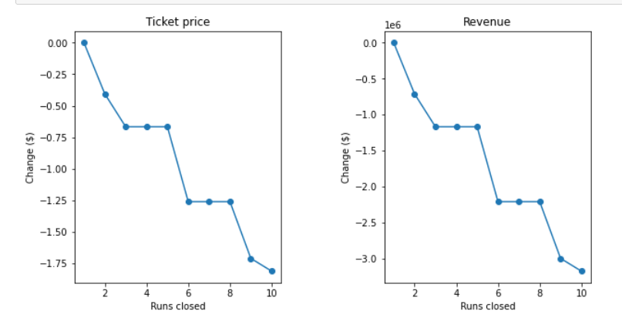
Here is a list of things I do not recommend. Having a longer trail seems to be a great advertising feature but based on the linear modeling we show that this will not support a price increase to our ticketing.

